**VICMAK SEQUENCE DIAGRAMS**

**A)CUSTOMER SIDE**

**1)ACCOUNT CREATION PROCESS**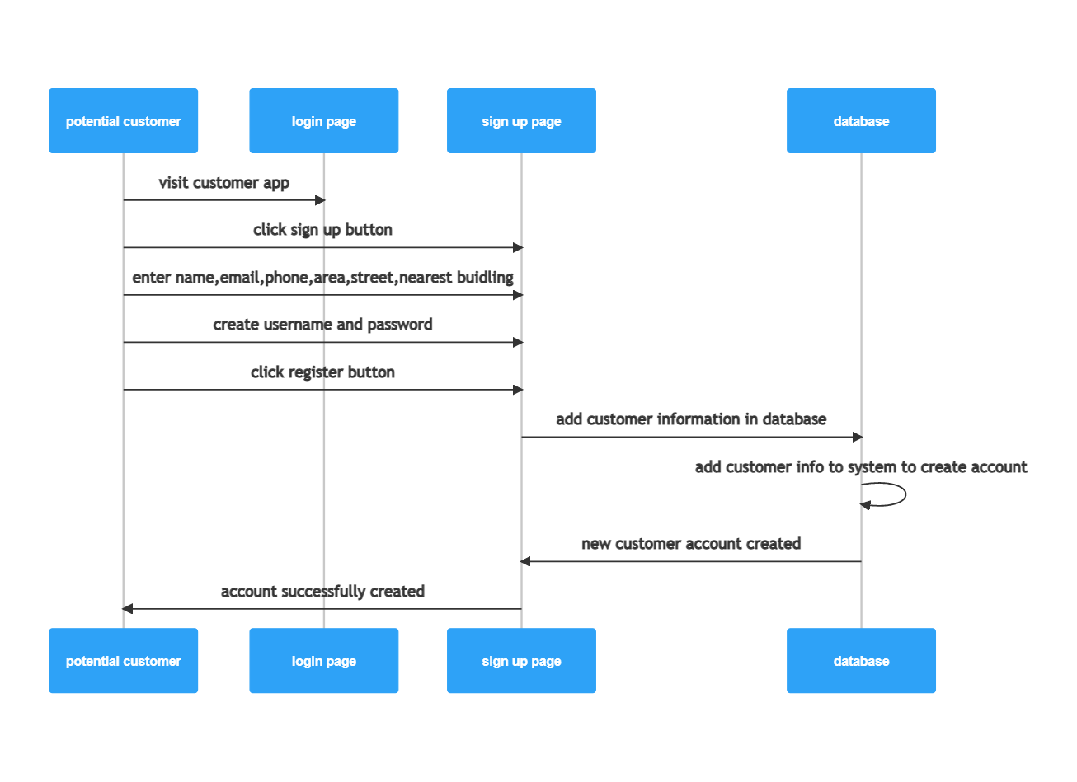

**2)User authentication process while logging in**

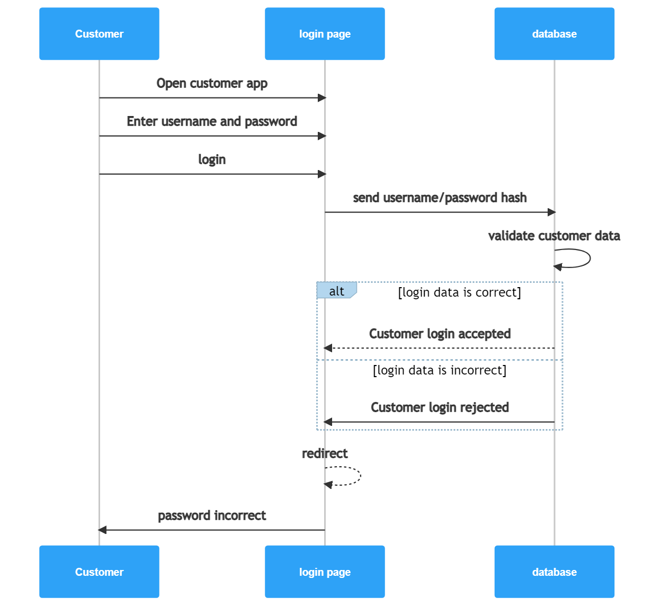

**3)Customer app navigation**

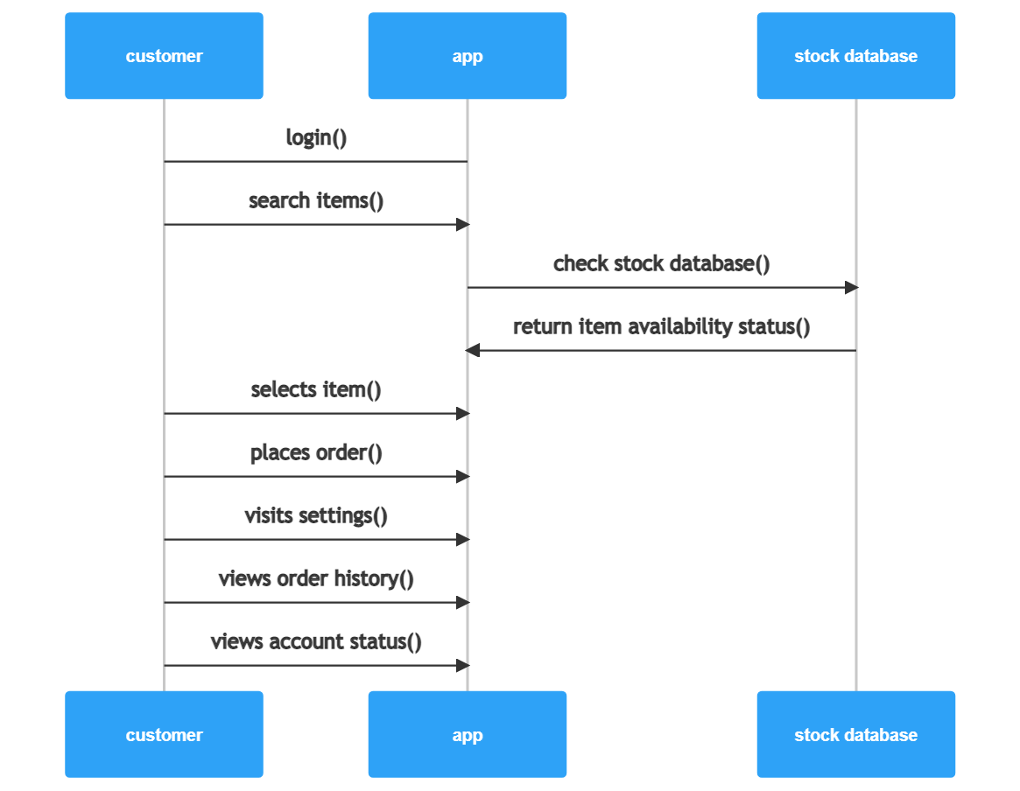

**4)Placing order-order management module**

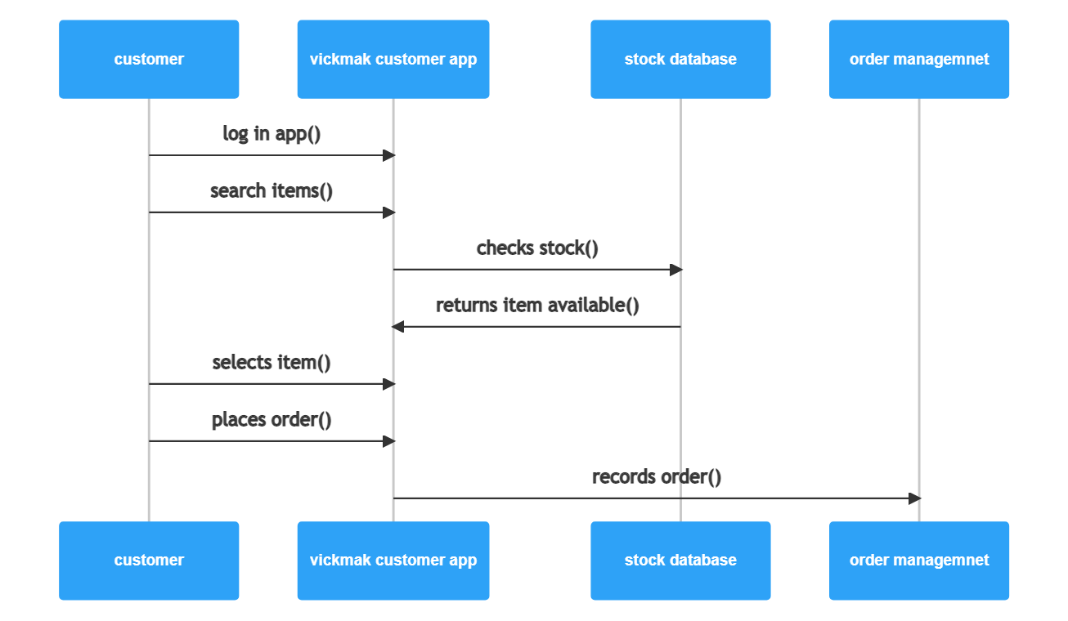

**B)ADMIN SIDE**

**1)ADMIN LOGIN AND AUTHENTICATION-user authentication**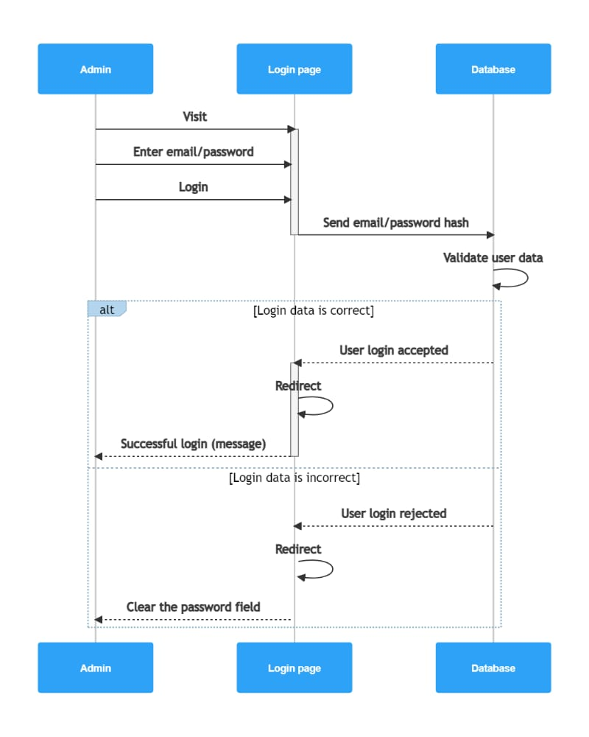

**2)Inventory-stock management module**

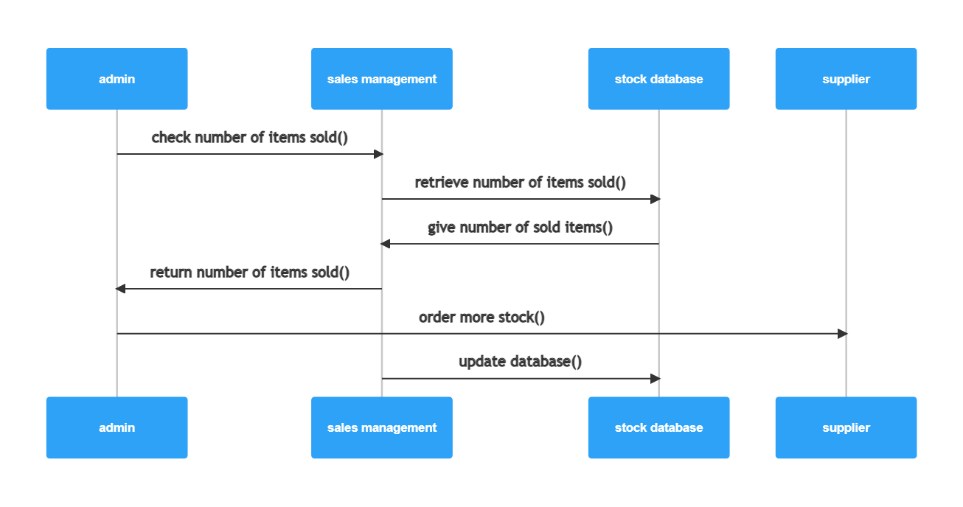

**3)delivery process-sales, user stock management** 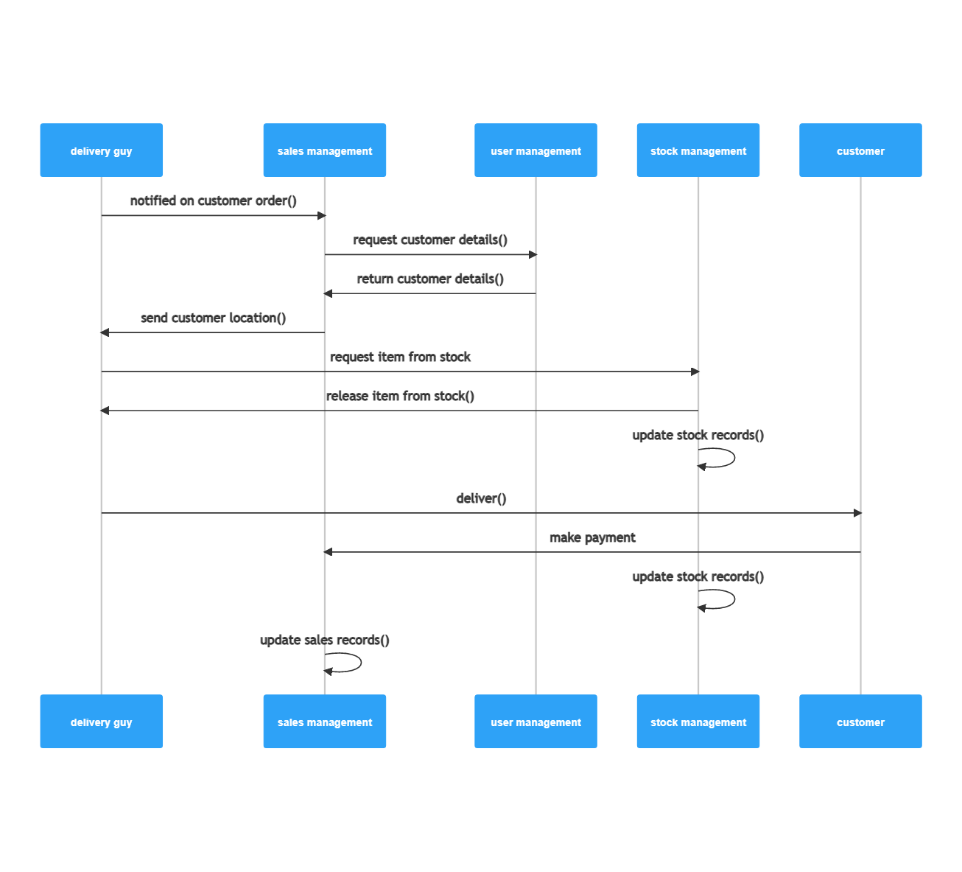

**4)user management process**

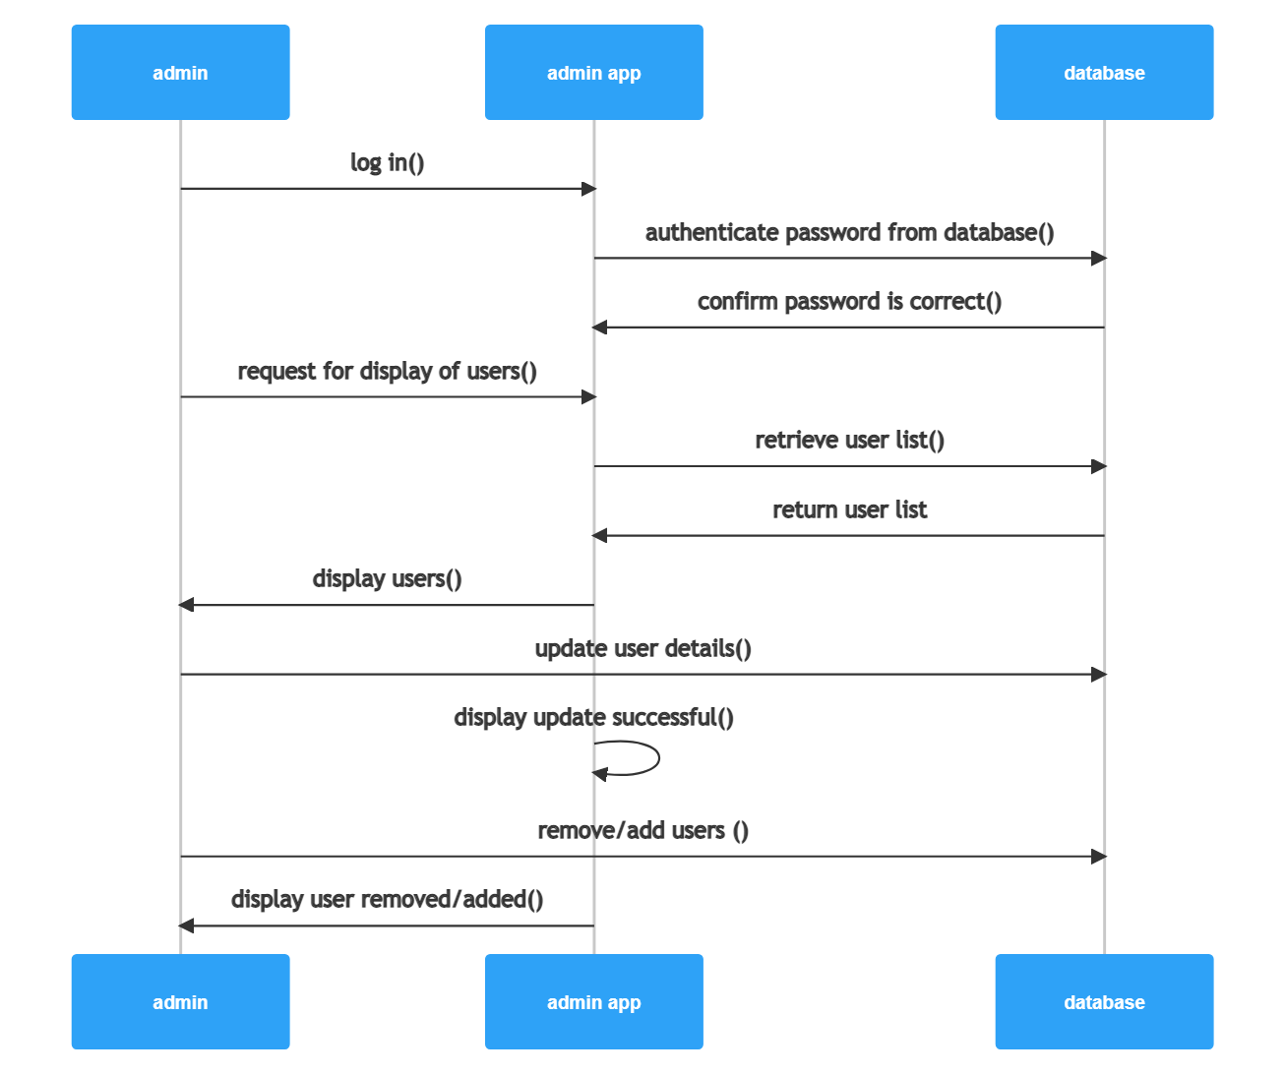

**Sales management**

